HPE - Assessment: Full stack developer
Version: 1.0
Created by: RYAN LE KIM HOANG

Introduction
I have developed a Spring MVC application, using Spring 5, Spring Boot 2, JSP and H2 database, which I self-named it as HPE - Restaurant Service and the artifact ID is HPE-Asmt

Tools and Technologies Used
- Spring Boot - v2.4.4
- JDK - v1.8 or later
- Spring Framework - v5.3.5
- Hibernate – v5.1.2
- JSTL – v1.2
- Embedded H2 Database
- Embedded Tomcat – v9.0
- Springfox Swagger2 – v3.0
- Maven - v3.5 or higher
- Eclipse IDE or Spring Tool Suite (STS)

Code Base Structure
HPE-Asmt
|_ src\main
|_ java\com\ryan\app
|_ HpeAsmtApplication.java
|_ common
|_ config
|_ controller
|_ dao
|_ dto
|_ facade
|_ model
|_ orm
|_ service
|_ resources
|_ application.properties
|_ h2-query.properties
|_ static
|_ css
|_ error
|_ images
|_ jquery
|_ js
|_ webapp
|_ WEB-INF
|_ jsp
|_ db
|_ ddl-dml.sql
|_ mydb.mv.db
|_ pom.xml

Endpoint APIs
No. | Path | HTTP Method | Description
1 | /index | GET | Main landing page
2 | /home | GET | Welcome & Introduction page
3 | /showlogin | GET | Login dialog
4 | /login | POST | Process user login
5 | /newuser | GET | Sign-up dialog
6 | /newuser/submit | GET | Process member registration
7 | /review/search | GET | Review Search page
8 | /review/result | POST | Review Search result
9 | /review/filtersort | POST | Review Search filtering
10 | /review/viewall | GET | Find Reviews by Restaurant
11 | /review/new | POST | New Review Input page
12 | /review/new/submit | POST | Review submission
13 | /owner/restaurant | GET | Find Restaurant by Owner page
14 | /owner/restaurant/edit | POST | Restaurant Edit page
15 | /owner/restaurant/update | POST | Process restaurant update
16 | /owner/restaurant/new | GET | Add New Restaurant page
17 | /owner/restaurant/insert | POST | Insert new restaurant record
18 | /menu/rest/search | GET | Menu Browsing page
19 | /menu/rest/result | POST | Menus filtering by Restaurants
20 | /menu/view | POST | Menu Detail page
Most of the APIs are Spring Controller which returning a view. I’m using Swagger2 for API documentation. Please refer to attached api-docs.json file for more details.

Database Configuration
I configured my Spring Boot application to connect an H2 file - mydb.mv.db (By design, the in-memory database is volatile, and data will be lost when we restart the application. Therefore, I’m using the file-based storage) with the username sa and the password sa. You may like to change those parameters in the application.properties file:
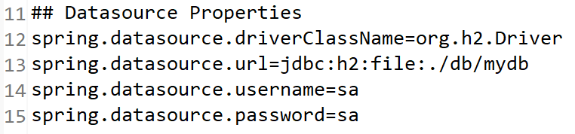

Running Application
- Java and Maven environment setup is required.
- To compile, open Command Prompt and navigate to parent folder of pom.xml file and execute this maven command:
mvn clean package
- To start application, simply Run the following command:
mvn spring-boot:run
- Open this application URL http://localhost:8080/index in browser to access the UI.
* Notes: I could not send the compiled WAR file over email, since it is about 56MB, and I also worry that your company’s network will block any executable-file transfer. I will upload to GitHub and share the link to you later. Sorry for this inconvenience.

Accessing the H2 Console
After starting the application, you can navigate to http://localhost:8080/h2-console that will present us with a login page. On the login page, you should enter the same credentials as we used in the application.properties:
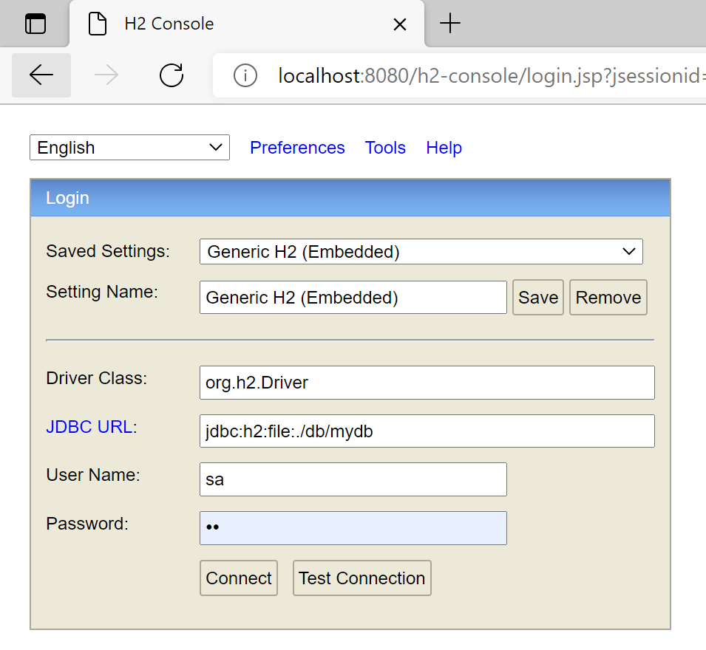
Once we connect, you will see a comprehensive webpage that lists all the tables on the left side of the page and a textbox for running SQL queries:
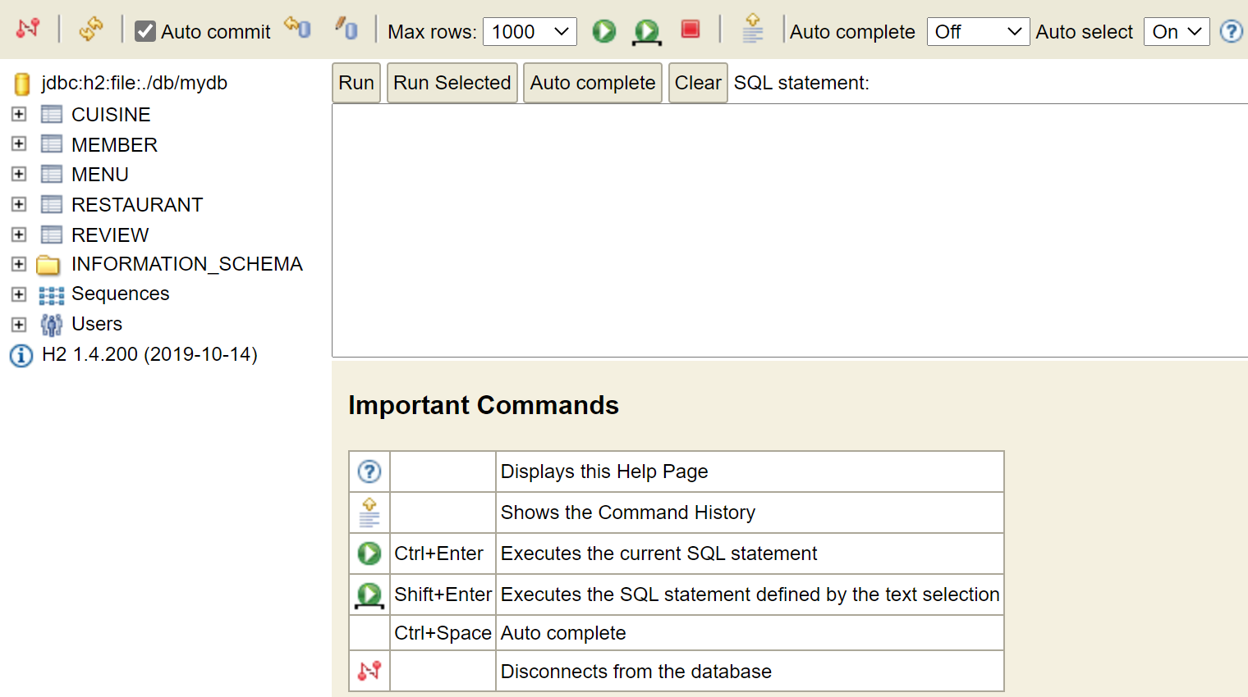

Global Exception Handler
I created a BaseController class to handle all common exception specifics single place which then redirects to the custom Error page or returns error-message to be displayed in UI.
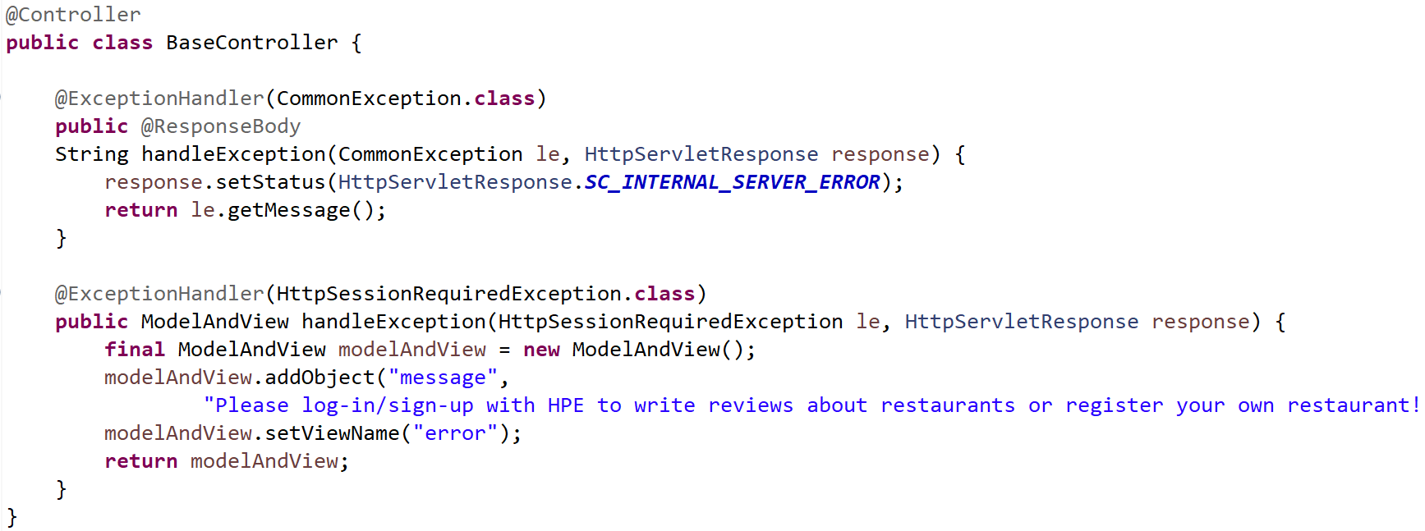

Database Definition

9.1. Member
FIELD | TYPE | NULL | KEY
USER_ID | VARCHAR(50) | NO | PRIMARY KEY
USER_PASSWORD | VARCHAR(100) | YES
FIRST_NAME | VARCHAR(30) | YES
MIDDLE_NAME | VARCHAR(30) | YES
LAST_NAME | VARCHAR(30) | YES
STREET_ADDRESS | VARCHAR(255) | YES
CITY | VARCHAR(100) | YES
STATE | VARCHAR(100) | YES
POSTAL | VARCHAR(10) | YES
PHONE_NUMBER | VARCHAR(25) | YES
EMAIL | VARCHAR(100) | YES
CC_NUMBER | VARCHAR(25) | YES
CARD_TYPE | VARCHAR(50) | YES
CC_EXPIRY_YY | INTEGER(10) | YES
CC_EXPIRY_MM | INTEGER(10) | YES
CC_HOLDER_NAME | VARCHAR(100) | YES

9.2. Restaurant
FIELD | TYPE | NULL | KEY
RESTAURANT_ID | BIGINT(19) | NO | PK
RESTAURANT_NAME | VARCHAR(100) | YES
DESCRIPTION | VARCHAR(255) | YES
STREET_ADDRESS | VARCHAR(255) | YES
CITY | VARCHAR(100) | YES
STATE | VARCHAR(100) | YES
POSTAL | VARCHAR(10) | YES
WEBSITE | VARCHAR(250) | YES
PHONE_NUMBER | VARCHAR(50) | YES
CUISINE_ID | INTEGER(10) | YES | FK
RESTAURANT_IMAGE | VARCHAR(250) | YES
OWNER_ID | VARCHAR(50) | YES | FK

9.3. Cuisine
FIELD | TYPE | NULL | KEY
CUISINE_ID | BIGINT(19) | NO | PK
CUISINE_NAME | VARCHAR(100) | YES

9.4. Menu
FIELD | TYPE | NULL | KEY
ITEM_CODE | BIGINT(19) | NO | PK
ITEM_NAME | VARCHAR(100) | YES
ITEM_CATEGORY | VARCHAR(100) | YES
DESCRIPTION | VARCHAR(255) | YES
PRICE | DECIMAL(8) | YES
QUANTITY | INTEGER(10) | YES
RESTAURANT_ID | INTEGER(10) | YES | FK

9.5. Review
FIELD | TYPE | NULL | KEY
REVIEW_NUMBER | BIGINT(19) | NO | PK
RESTAURANT_ID | INTEGER(10) | YES | FK
USER_ID | VARCHAR(50) | YES | FK
RATING | INTEGER(10) | YES
COMMENTS | VARCHAR(255) | YES
REVIEW_DATETIME | VARCHAR(100) | YES

User Interfaces:

Home page
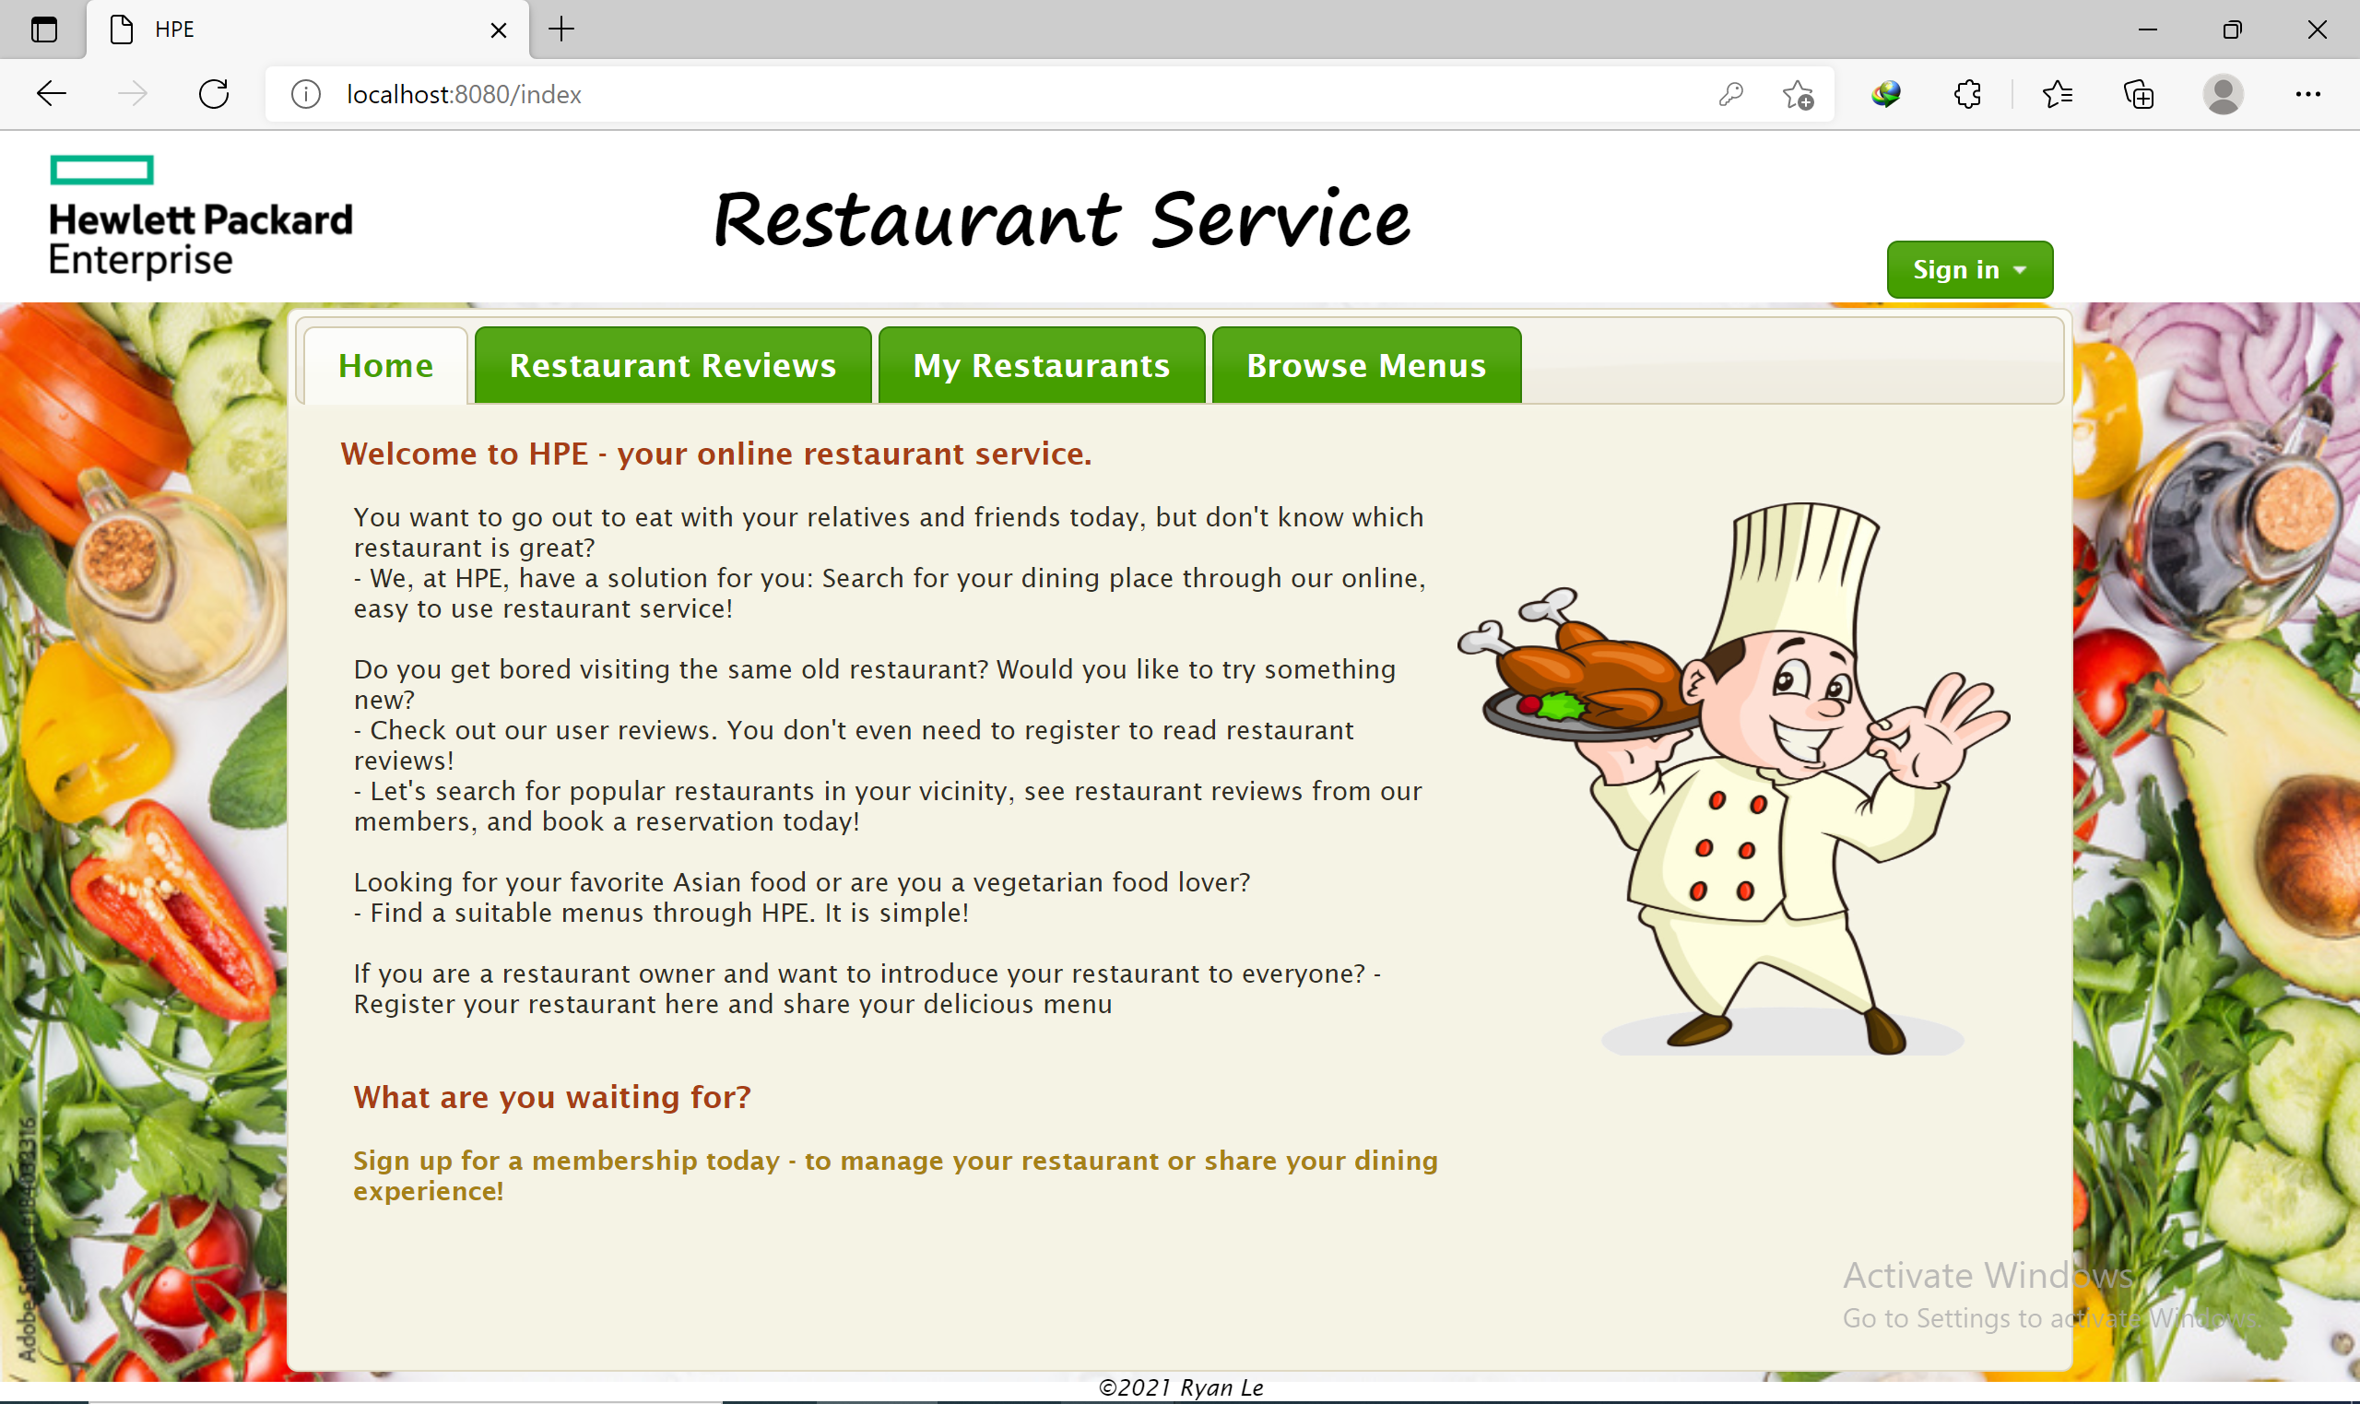

User Login
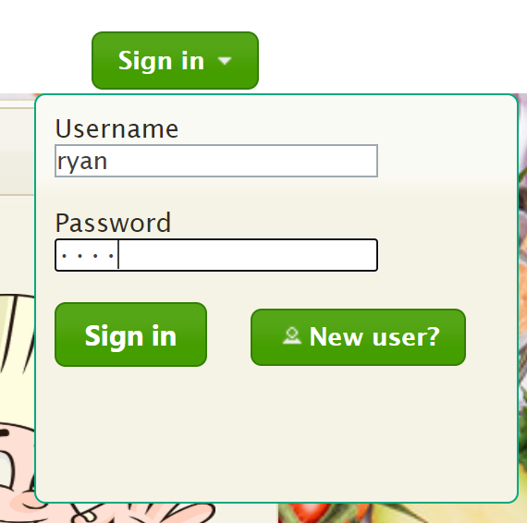

Member Registration
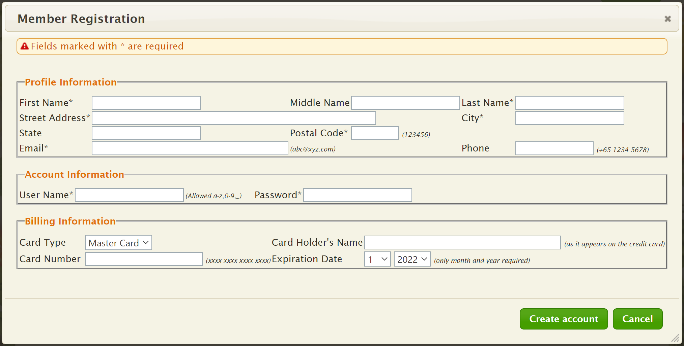

Restaurant Reviews
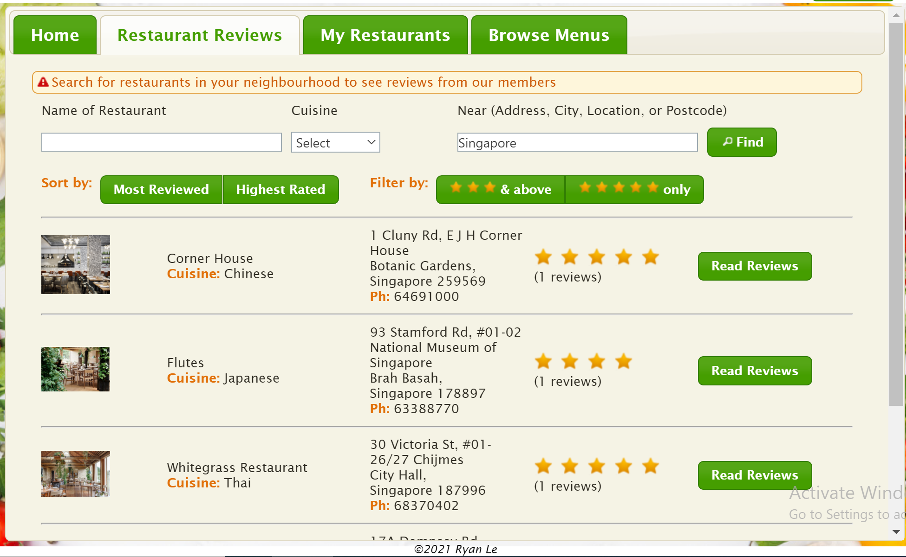

Read Reviews
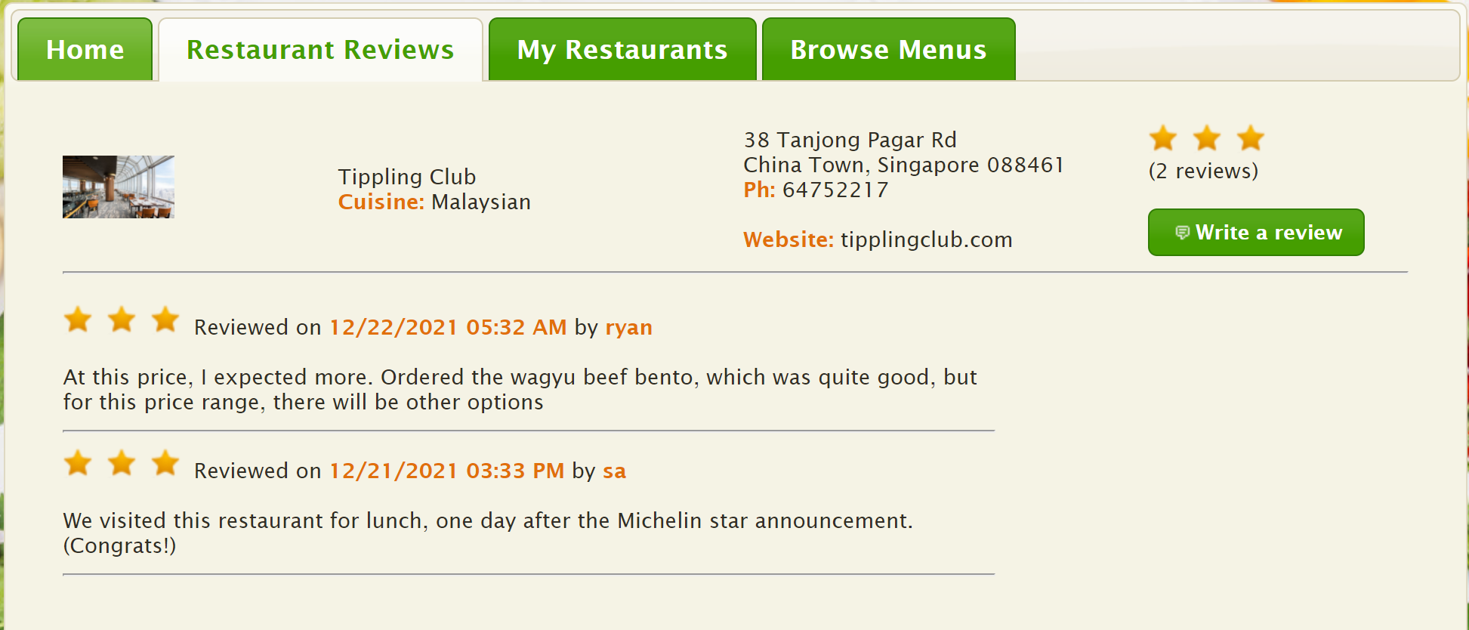

Write Review
without login, it cannot be procceeded
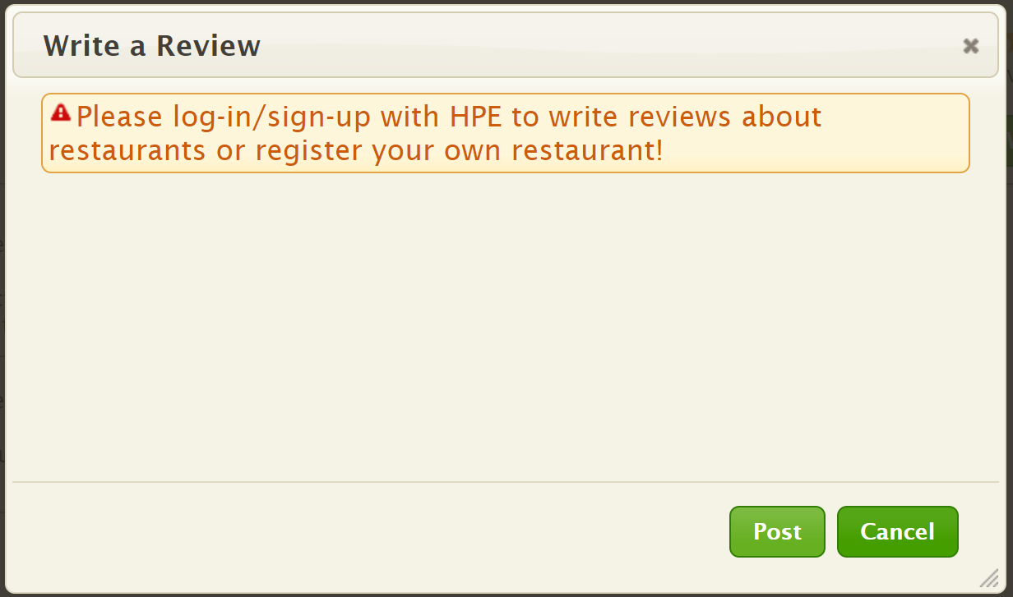
After sign-in
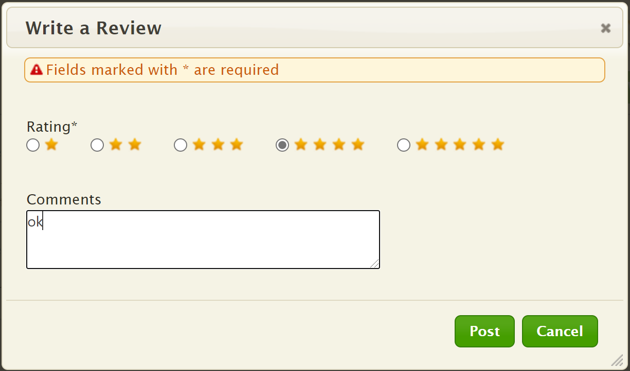

Owner Manage Restaurants
Without login, it cannot be accessed
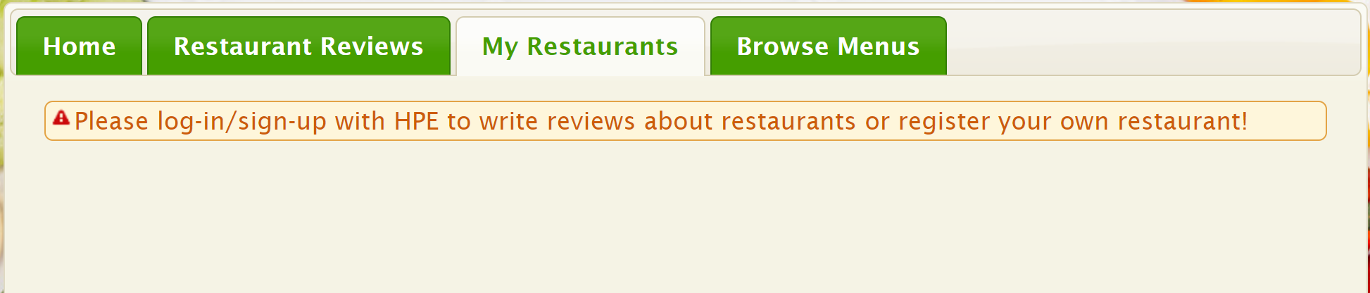
After sign-in
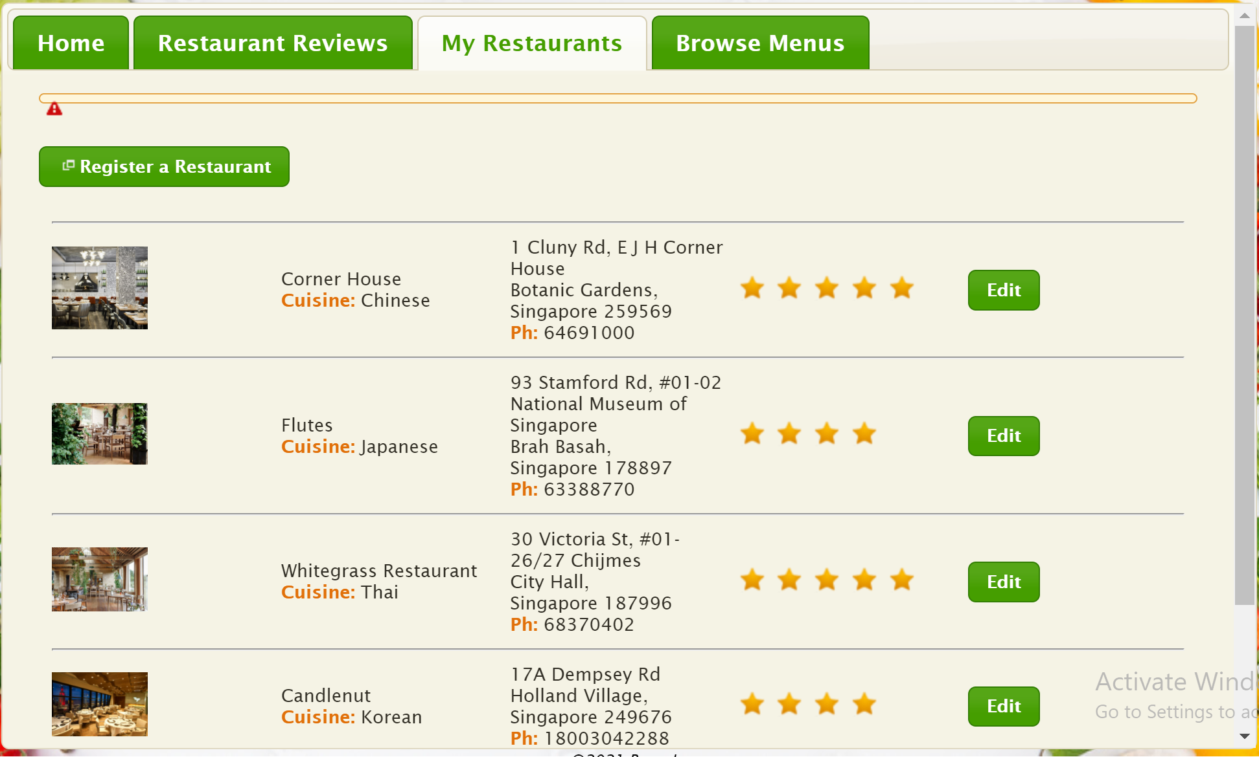

Register Restaurant
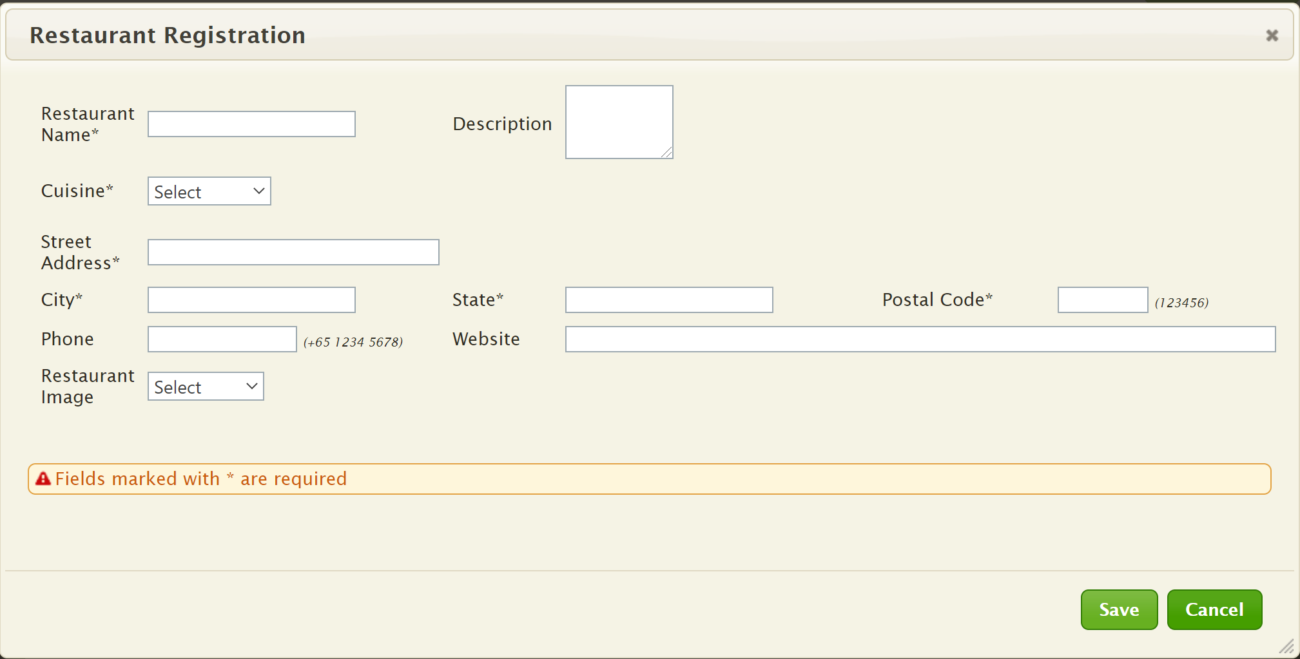

Edit Restaurant Info
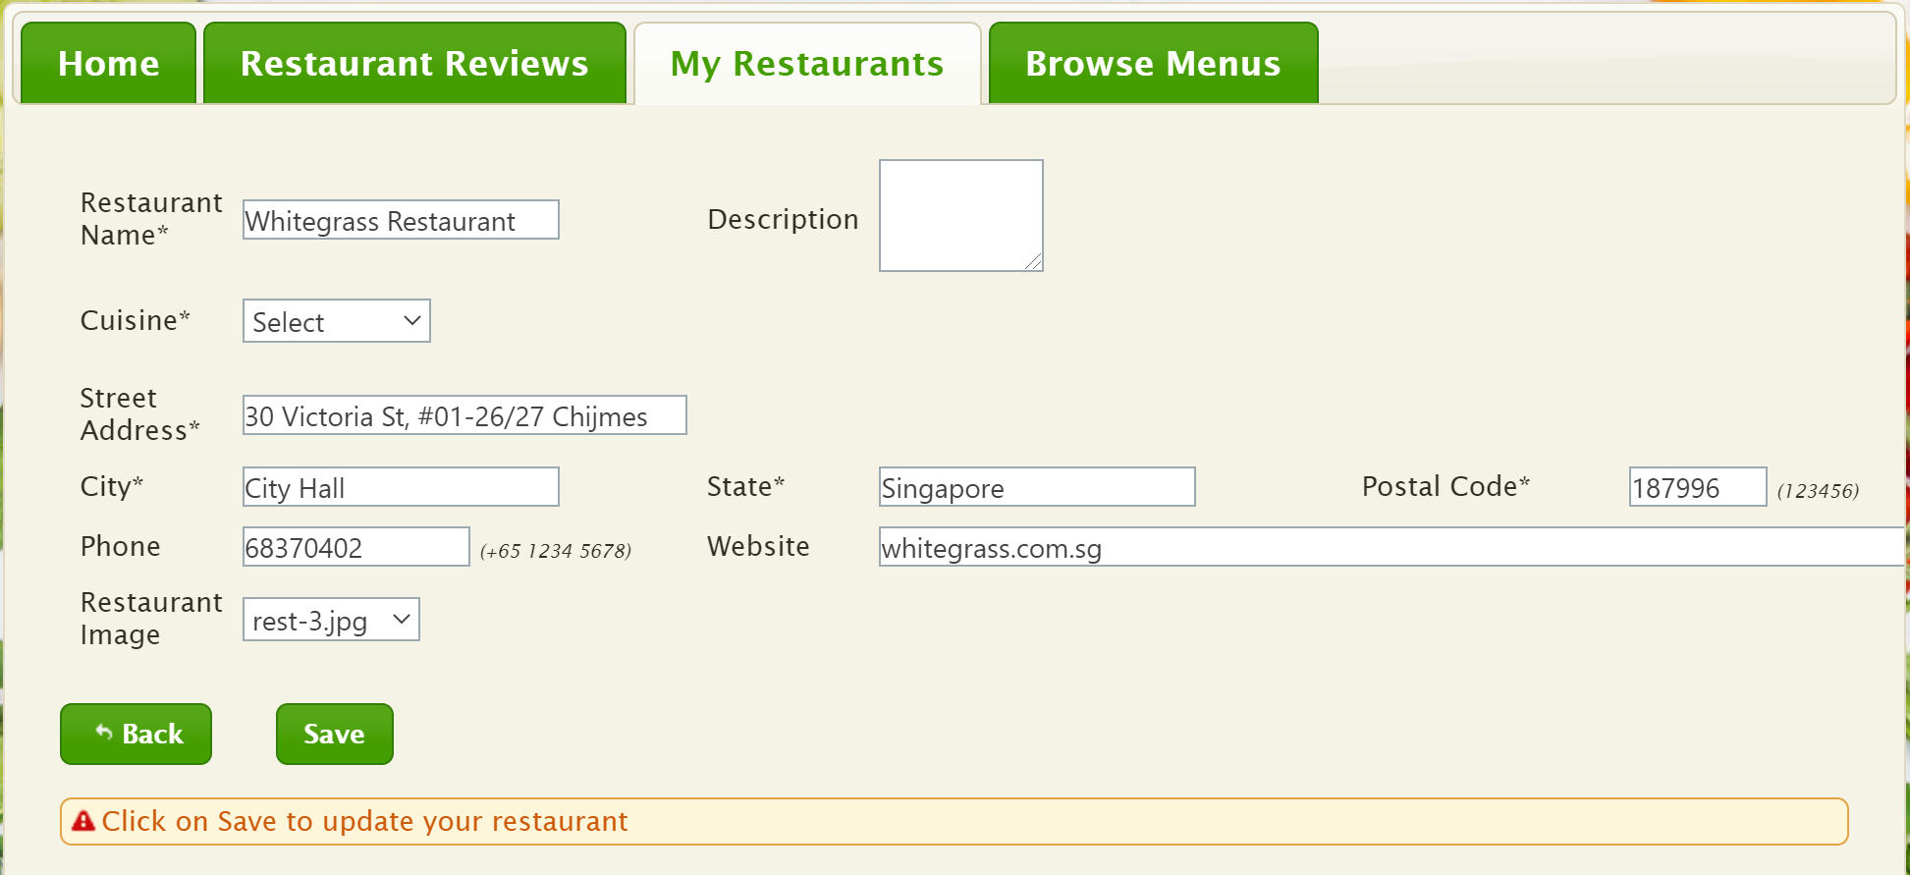

Browse Menu
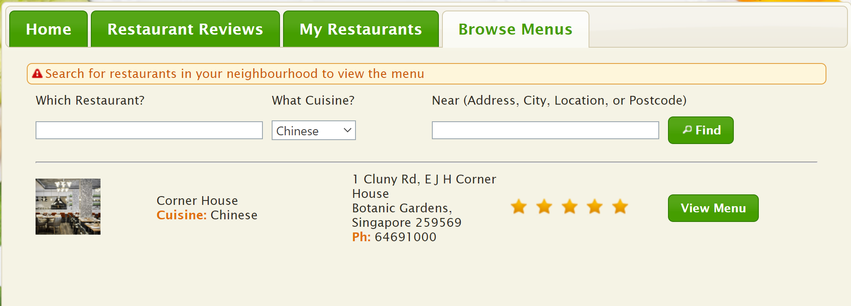

Menu Details
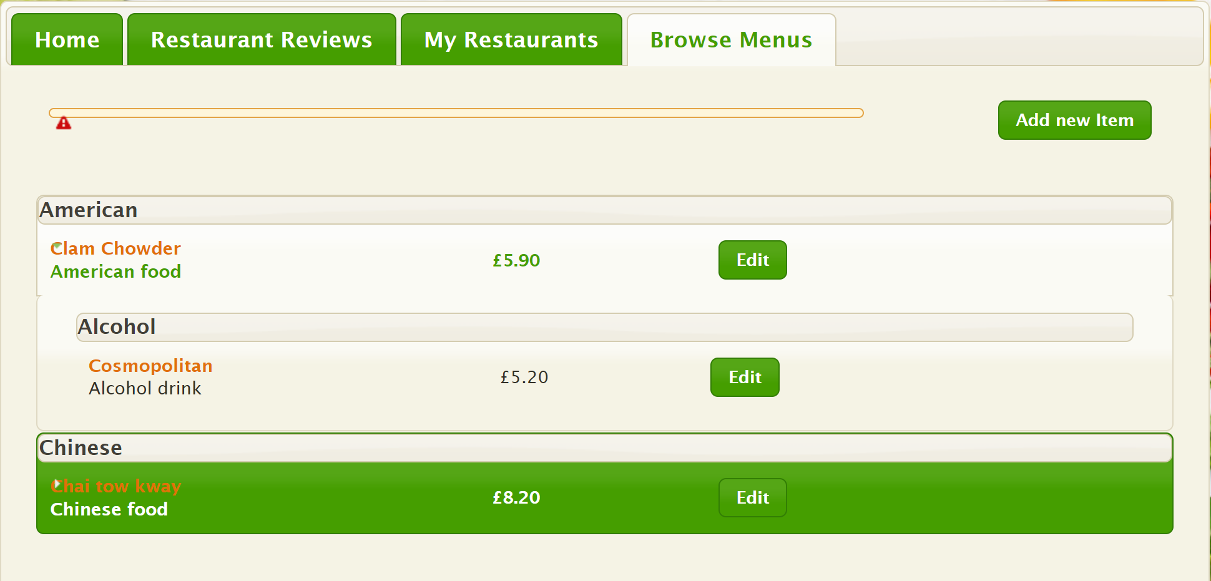

11. Limitations and Outstanding Problems
- Due to limited time, the menu upload function is still incomplete. I sincerely apologize for this inconvenience.
- In addition, users cannot edit the menu yet. This along with the above point will need to be improved in a later version.
- The interface is not yet harmonious and user-friendly. There are many potential bugs existing.
- There is no function to upload images for the restaurant. At the same time, the data binding is not tight.
I look forward to receiving your honest feedback. Thank you so much for taking the time to review my application!

